

FORMS MANUAL

(FM)

CRS# TBD

1887 SOUTH 1800 WEST

Woods Cross, UT 84087

# REVISION LIST

|  |  |
| --- | --- |
| V1.00 | Initial Release |
|  |  |

# LIST OF EFFECTIVE PAGES

|  |  |  |  |  |  |  |  |
| --- | --- | --- | --- | --- | --- | --- | --- |
|  |  |  |  |  |  |  |  |
|  |  |  |  |  |  |  |  |
|  |  |  |  |  |  |  |  |

# REVISION HIGHLIGHTS

# MANUAL CONTROL

This manual will be stored on Alta Avionics main computer or by hardcopy. Each employee will be trained on the procedure to access all the manuals at the time of hiring. In addition, a printed copy will be kept in the repair station’s General Manager’s office.

The General Manager will be notified by a department supervisor in the event this manual is not current, and valid for that department’s use, and will identify needed changes using form AA-MCR (Manual Change Request).

A sample of this form is found herein. The General Manager will have the revisions found necessary, produced in a final form. The proposed revisions will be submitted to the FAA/CHDO (Certificate Holding District Office) in electronic format (PDF) for acceptance.

The FAA Coordinator will revise manuals as required, and explain the revisions to all employees.

An entry into each employee’s training record will be added after each employee has been trained to verify and acknowledge the understating of each revision.

Upon approval by an authorized Repair Station representative, the repair station will commence operating within the guidelines of the new revision. The “List of Effective Pages” will reflect the Approval/Acceptance of the current revision. A file will be maintained, showing on a continuous basis, the disposition of each manual change. The FAA/CHDO will be notified each time a revision to this manual is needed. Revised areas will be identified by a vertical bar in the margin.

Revisions found “un-acceptable” to the FAA/CHDO, which do not conform to applicable regulations, will be addressed by this repair station as a top priority. The identified procedure or action will cease, and acceptable changes implemented immediately. The maintenance/administrative actions that were performed under revisions found “unacceptable” by the FAA/CHDO will be addressed in the following order:

Safety of Flight: Aircraft operator to be notified immediately, and advised that aircraft is to remain on the ground until this repair station can correct the problem, or coordinate with another certified repair station to correct the problem.

Procedure/Record Keeping: Aircraft operator to be notified immediately, and advised of the problem. The operator will have the option to operate the aircraft until the problem can be corrected.

Problems that do not affect aircraft and/or appliances will be dealt with internally and immediately, to correct them.

# SATTELITE FACILITIES

All computer generated forms will have the option to select the appropriate facility. This will enable all forms to display the correct address and CRS#.

All non-computer generated forms that specify location or CRS number will have either all locations displayed or all CRS numbers displayed to comply with previous FAA accepted forms.

# TABLE OF CONTENTS

1-1-1 REVISION LIST 2

1-1-2 LIST OF EFFECTIVE PAGES 2

1-1-3 REVISION HIGHLIGHTS 2

1-1-4 MANUAL CONTROL 3

1-1-5 SATTELITE FACILITIES 3

1-1-6 TABLE OF CONTENTS 4

1-1-7 AA-MCR - MANUAL CHANGE REQUEST 6

1-1-8 AA-25 - EMPLOYTRAINING RECORD 7

1-1-9 AA-RTL – REQUIRED TRAINING LOG 8

1-1-10 AA-AUD-AFCA – AUDIT FINDINGS/CORRECTIVE ACTION 9

1-1-11 AA-AUD-AFCL – AUDIT FINDINGS CONTROL LOG 10

1-1-12 AA-AUD-AR - AUDIT REQUEST 11

1-1-13 AA-AUD-IA - INTERNAL AUDIT 12

1-1-14 AA-AUD-VA – VENDOR AUDIT 15

AA-AUD-VA – VENDOR AUDIT (continued) 17

1-1-15 AA-AUD-CVA - CALIBRATED VENDOR AUDIT 18

1-1-16 AA-WO – WORK ORDER 21

1-1-17 AA-IIC - INSTALLATION INSPECTION CHECKLIST 22

1-1-18 FORMAT OF LOGBOOK ENTRIES 24

1-1-19 AA-LE-GAMR - LOG ENTRY FORMAT 24

1-1-20 AA-LE-ACMR – AIR CARRIER MAINTENANCE RELEASE 25

1-1-21 AA-LE-ATI - LOG ENTRY ALTIMETER TEST AND INSPECTIONS 26

1-1-22 FAA 8130-3 27

1-1-23 AA-CC – CERTIFICATE OF CALIBRATION 27

1-1-24 AA-CLEF - CAPABILITIES LIST SELF EVALUATION 28

1-1-25 AA-CSDS – COMPASS SWING DOCUMENT SHEET 30

1-1-26 AA-ECTCR – ELECTROMAGNETIC COMPATABILITY TEST COMPLETION RECORD 31

1-1-27 AA-ATI-ALTIMETER TEST AND INSPECTION 32

1-1-28 AA-MACS -MASTER ALTIMETER CORRECTION SHEET 33

1-1-29 AA-TS – TESTED STICKER 34

1-1-30 AA-CS – CALIBRATION STICKER 34

1-1-31 AA-ML MANUAL LABEL 34

1-1-32 AA-ID - ID TAG 35

1-1-33 AA-SLI SHELF LIFE ITEM 35

1-1-34 AA-RAS – REMOVED AS SERVICABLE 36

1-1-35 AA-REP REPAIRABLE EQUIPMENT/PARTS 36

1-1-36 AA-RFS REPAIRABLE FOR STORAGE 37

1-1-37 AA-RIT – REJECT ITEM TAG 37

1-1-38 AA-ST SCRAP TAG 37

1-1-39 AA-SPL – SCRAPPED PARTS LOG 38

1-1-40 AA-TECIF – TEST EQUIPMENT CALIBRATION AND INSPECTION FORM 39

# AA-MCR - MANUAL CHANGE REQUEST

Used to request a change any of Alta Avionics, LLC manuals. This form will be completed and given to the General Manager. The manuals may be revised if deemed necessary.

|  |  |
| --- | --- |
| AA-MCR - INSTRUCTIONS FOR FORM USE   1. Self-explanatory 2. Self-explanatory 3. Self-explanatory 4. The employee requesting the manual change must sign 5. The employee requesting the manual change must date 6. The QA manager, Chief Inspector, or General manager will select one of the three status boxes 7. The QA manager, Chief Inspector, or General manager will outline what actions are to be taken (e.g. revise the manual, reject the request, etc.) 8. The QA manager, Chief Inspector, or General manager will sign and date the completed form   **NOTE**: Not all fields always require text entry. Contact your supervisor if there are questions. In cases where data is not required, DO NOT leave blank; enter N/A. | AA-MCR – MANUAL CHANGE REQUES SAMPLE FORMT |

# AA-25 - EMPLOYTRAINING RECORD

Used to document ongoing and recurrent training of all employees of Alta Avionics LLC. Completed forms will be scanned into the appropriate employee training records.

|  |  |
| --- | --- |
| AA-25 - INSTRUCTIONS   1. Enter the full name of the Employee 2. Enter the Certificate number (A, P, A/P, Repairman, etc.) 3. Enter the type of training (e.g. OJT, Classroom, Distant, etc.) 4. Enter the duration/length of training, in hours 5. Enter the location of training (organization, facility, factory, etc.) 6. Enter the name of the qualified instructor 7. Enter the date the training occurred (the day it was completed) 8. Enter Yes, or No, denoting whether the training was successful to establish proficiency in the skill being trained 9. Apply Employee signature to the completed form 10. Apply Supervisor’s signature to the completed form 11. Enter the date on which the employee Training Records were updated 12. Enter the name of the person updating the employee Training Records   NOTE: Not all fields always require text entry. Contact your supervisor if there are questions. In cases where data is not required, DO NOT leave blank; enter N/A. | AA-25 - SAMPLE FORM |

# AA-RTL – REQUIRED TRAINING LOG

This form is used to document required training for employees. This form will be completed and maintained by the employee’s supervisor, showing the type, date, and who trained the employee. This form will be added to the employee’s Training Records.

|  |  |
| --- | --- |
| AA-RTL – INSTRUCTIONS   1. Enter Employee full Name 2. Enter Employee original Hire Date 3. Enter Position currently held 4. Enter Supervisor Initials 5. For each Training Type listed;    1. Note the Training Type frequency (this is used to track recurring training)    2. Place the date the training was provided    3. Place the Instructor’s full name in the space adjacent to the Training Type    4. Enter notes as necessary   **NOTE**: Not all fields always require text entry. Contact your supervisor if there are questions. In cases where data is not required, DO NOT leave blank; enter N/A. | AA-RTL - SAMPLE |
|  |  |

# AA-AUD-AFCA – AUDIT FINDINGS/CORRECTIVE ACTION

This form is used to document findings and corrective actions for audits. Upon completion, forms filed with appropriate audits.

|  |  |
| --- | --- |
| AA-AUD-AFCA INSTRUCTIONS  1) Enter the name of the Company undergoing the Audit  2) Enter the name of a primary point of contact for the Company undergoing the Audit  3) Enter the physical address of the facility, of the Company undergoing the Audit  4) Enter the telephone number of the Company, or point of contact for the Company undergoing the audit  5) Discrepancy; enter a brief description of the discrepancy reported, or discovered during the audit; circle either ‘New’ or ‘Repeat’, as appropriate  6) Auditor; provide the name of the person performing the audit  7) Date; enter the date the audit was completed Internal Audit;  8) Enter the Department or Area undergoing the Audit  9) Discrepancy; enter a brief description of the discrepancy reported, or discovered during the audit; circle either ‘New’ or ‘Repeat’, as appropriate  10) Auditor; provide the name of the person performing the audit  11) Date; enter the date the audit was completed  12) Root Cause; enter a clear definition of the root cause and corrective action, in sufficient detail so as to aid in resolution of the discrepancy, and avoid repeats  13) Place the signature of the person taking corrective action on this line  14) Date; enter the date the person corrected the discrepancy  15) Place the name of the auditor on this line  16) Date; enter the date the corrective action was verified by the auditor  NOTE: Not all fields always require text entry. Contact your supervisor if there are  questions. In cases where data is not required, DO NOT leave blank; enter N/A. | AA-AUD-AFCA SAMPLE FORM |

# AA-AUD-AFCL – AUDIT FINDINGS CONTROL LOG

Used to keep a tally of audit findings which are the result of an audit. Upon completion, forms are achieved.

|  |  |
| --- | --- |
| AA-AUD-AFCL INSTRUCTIONS  1) Department; enter the name of the audited department (this is a running tally for that department only)  2) Audit Type; enter the Audit Type, as defined in the audit plan  3) Audit Date; date on which the audit is scheduled, or has commenced  4) Comments; enter a brief description of the Audit Finding (as taken from the AA-AUD-AFCA (Audit Finding and Corrective Actions form)  5) Closing Date; the date on which a qualified Auditor accepts the Corrective Action (items 15 and 16 on the AA-AUD-AFCA form)  NOTE: Not all fields always require text entry. Contact your supervisor if there are questions. In cases where data is not required, DO NOT leave blank; enter N/A. | AA-AUD-AFCL SAMPLE  /Users/croe10/workspace/RepairServiceManual/FM/AA-FORMS/AA-AUD-AFCL/AA-AUD-AFCL.pdf |

# AA-AUD-AR - AUDIT REQUEST

This form is used to request a new vendor, current vendor, or internal audit.

|  |  |
| --- | --- |
| AA-AUD-AR - INSTRUCTIONS  1) Type of Audit; if a new vendor, enter an X on the New Vendor line  2) Type of Audit; if current vendor, enter an X on the Current Vendor line  3) Enter the Company name of the Vendor undergoing the audit  4) Enter the Company address of the vendor undergoing the audit  5) Enter the telephone number of the Company undergoing the audit  6) Internal Audit; enter an X on the appropriate line;  a) Service  b) Installation  c) Instrument  d) Parts/Shipping  7) Reason; enter a description of the reason for the audit (e.g. non-conforming work/material, routine scheduled, etc.)  8) Enter the name or organization requesting the audit  9) Enter the date of the Audit Request  NOTE: Not all fields always require text entry. Contact your supervisor if there are questions. In cases where data is not required, DO NOT leave blank; enter N/A. | AA-AUD-AR - SAMPLE  \ |

# AA-AUD-IA - INTERNAL AUDIT

Used for the internal audit function of the different departments and/or areas within the company. Upon completion, forms are to be filedf.

AA-AUD-IA - INSTRUCTIONS

1. Enter the date of the Audit (scheduled or otherwise)

2. Enter the title of the Facility undergoing the Audit (e.g. Henderson, Apple Valley, etc.)

3. Enter the repair station certificate number

4. Enter the name of the department or area undergoing the Audit (e.g., Stock Room, Repaired Unit Storage Area, etc.)

5. Enter the name of the Supervisor responsible for the department or area undergoing the audit

6. Enter the name of the Auditor

7. Enter the typical interval or scheduled Audit Interval

8. Enter a brief description of Recommendations under which the Audit will be conducted

9. Facilities and Equipment; these audit element questions are self-explanatory, review and answer all audit element questions

10. Authority and Limitations and Actual Practices; these audit element questions are self-explanatory, review and answer all audit element questions

11. Personnel Qualifications and Training; these audit element questions are self-explanatory, review and answer all audit element questions

12. Manuals and Airworthiness Data; these audit element questions are self-explanatory, review and answer all audit element questions

13. Supplier Selection Approval and Surveillance; these audit element questions are self-explanatory, review and answer all audit element questions

14. Parts and Materials Handling; these audit element questions are self-explanatory, review and answer all audit element questions

15. Inspection and Quality Control; these audit element questions are self-explanatory, review and answer all audit element questions

16. Tool Adequacy and Calibration; these audit element questions are self-explanatory, review and answer all audit element questions

17. Maintenance Release Process; these audit element questions are self-explanatory, review and answer all audit element questions

18. Defect Reporting; these audit element questions are self-explanatory, review and answer all audit element questions

19. Records and Recordkeeping; these audit element questions are self-explanatory, review and answer all audit element questions

20. Shelf Life; these audit element questions are self-explanatory, review and answer all audit element questions

NOTE: Not all fields always require text entry. Contact your supervisor if there are questions. In cases where data is not required, DO NOT leave blank; enter N/A.

AA-AUD-IA SAMPLE

|  |  |
| --- | --- |
|  |  |
|  |  |

-AUD-IA SAMPLE (continued)

|  |  |
| --- | --- |
|  |  |

# AA-AUD-VA – VENDOR AUDIT

This form is used for vendor audit and evaluation. Upon completion and approval of this form, a vendor may be placed on the Approved Vendor List, and filed with vendor audits.

AA-AUD-VA – INSTRUCTIONS

Note: not all areas of the repair station are subject to all of the audit elements contained in this Audit Checklist. Where audit elements are not applicable, place an X in the N/A column for that element.

1. Enter Distributor Company name

2. Enter Distributor address

3. Enter Distributor city

4. Enter Distributor State

5. Enter Distributor Zip Code

6. Annotate the particular division of the Distributor Company

7. Enter the Distributor telephone number

8. Enter the Distributor fax number

9. Enter the number of years the Distributor has been in operation at the specific location

10. Enter the number of employees maintained by the Distributor

11. Company Contacts;

a. Enter the name of the primary point of contact for Distributor Quality Control

b. Enter the phone number of the Quality Control contact

c. Enter the name of the primary point of contact for Distributor Inspection

d. Enter the phone number of the Inspection contact

e. Enter the name of the primary point of contact for Distributor Material Control

f. Enter the phone number of the Material Control contact

12. Alta Avionics Audit Details

a. Enter Distributor Category

b. Enter an X on the appropriate line for Audit Type

c. Enter the recommended audit interval in months

d. Status;

i. Enter an X on the appropriate line for Acceptance, Conditional Acceptance, or Not Accepted

e. Circle one of the recommendations of Distributor status (approved vendor list); Add, Delete (remove), Update, Does not Qualify

f. Enter the date at which the next scheduled audit will take place

g. Auditor applies signature and date the form and audit are completed

13. Quality Control System; these audit element questions are self-explanatory, review and answer all audit element questions

14. Measuring and Test Equipment Calibration (standards); these audit element questions are self-explanatory, review and answer all audit element questions

15. Technical Data; these audit element questions are self-explanatory, review and answer all audit element questions

16. Records; these audit element questions are self-explanatory, review and answer all audit

17. element questions

18. Shelf Life Program; these audit element questions are self-explanatory, review and answer all audit element questions

19. Training; these audit element questions are self-explanatory, review and answer all audit

20. element questions

21. Procurement; these audit element questions are self-explanatory, review and answer all audit element questions

22. Material Control; these audit element questions are self-explanatory, review and answer all audit element questions

23. Housing and Facilities; these audit element questions are self-explanatory, review and answer all audit element questions

24. Repair Station; these audit element questions are self-explanatory, review and answer all audit

25. element questions

26. Drug and Alcohol Program; these audit element questions are self-explanatory, review and answer all audit element questions

NOTE: Not all fields always require text entry. Contact your supervisor if there are questions. In cases where data is not required, DO NOT leave blank; enter N/A.

AA-AUD-VA – SAMPLE

|  |  |
| --- | --- |
| /Users/croe10/workspace/RepairServiceManual/FM/AA-FORMS/AA-VA/AA-VA page1.pdf | /Users/croe10/workspace/RepairServiceManual/FM/AA-FORMS/AA-VA/AA-VA page2.pdf |
| /Users/croe10/workspace/RepairServiceManual/FM/AA-FORMS/AA-VA/AA-VA page3.pdf | /Users/croe10/workspace/RepairServiceManual/FM/AA-FORMS/AA-VA/AA-VA page4.pdf |

# AA-AUD-VA – VENDOR AUDIT (continued)

|  |  |
| --- | --- |
| /Users/croe10/workspace/RepairServiceManual/FM/AA-FORMS/AA-VA/AA-VA page5.pdf | /Users/croe10/workspace/RepairServiceManual/FM/AA-FORMS/AA-VA/AA-VA page6.pdf |

# AA-AUD-CVA - CALIBRATED VENDOR AUDIT

Used for calibrated equipment vendor vetting, audit and evaluation. Upon completion and approval of this form, a vendor may be placed on the Approved Vendor List.

AA-AUD-CVA INSTRUCTIONS

Note: not all areas of the repair station are subject to all of the audit elements contained in this Audit Checklist.

Where audit elements are not applicable, place an X in the N/A column for that element.

1. Enter Vendor Company name
2. Enter Vendor address
3. Enter Vendor city
4. Enter Vendor State
5. Enter Vendor Zip Code
6. Annotate the particular division of the Vendor Company
7. Enter the Vendor telephone number
8. Enter the Vendor fax number
9. Enter the number of years the Vendor has been in operation at the specific location
10. Enter the number of employees maintained by the Vendor
11. Company Contacts;
    1. Enter the name of the primary point of contact for Vendor Quality Control
    2. Enter the phone number of the Quality Control contact
    3. Enter the name of the primary point of contact for Vendor Inspection
    4. Enter the phone number of the Inspection contact
12. Alta Avionics Audit Details
    1. Enter Vendor Category
    2. Enter an X on the appropriate line for Audit Type
    3. Enter the recommended audit interval in months
    4. Status;
    5. Enter an X on the appropriate line for Acceptance, Conditional Acceptance, or Not Accepted
    6. Circle one of the recommendations of Vendor status (approved vendor list); Add, Delete (remove), Update, Does not Qualify
    7. Enter the date at which the next scheduled audit will take place
    8. Auditor applies signature and date the form and audit are completed
13. Quality Assurance System; these audit element questions are self-explanatory, review and answer all audit element questions
14. Technical Data; these audit element questions are self-explanatory, review and answer all audit element questions
15. Training; these audit element questions are self-explanatory, review and answer all audit element questions
16. Measuring and Test Equipment Calibration (standards); these audit element questions are self-explanatory, review and answer all audit element questions
17. Work Processing; these audit element questions are self-explanatory, review and answer all audit element questions
18. Records; these audit element questions are self-explanatory, review and answer all audit element questions
19. Facilities; these audit element questions are self-explanatory, review and answer all audit element questions
20. Certificates and Reports; these audit element questions are self-explanatory, review and answer all audit element questions
21. Shipping; these audit element questions are self-explanatory, review and answer all audit element questions
22. Shelf Life Program; these audit element questions are self-explanatory, review and answer all audit element questions
23. Electrostatic Discharge Procedures; these audit element questions are self-explanatory, review and answer all audit element questions
24. Drug and Alcohol Program; these audit element questions are self-explanatory, review and answer all audit element questions
25. Repair Station; these audit element questions are self-explanatory, review and answer all audit element questions

**NOTE**: Not all fields always require text entry. Contact your supervisor if there are questions. In cases where data is not required, DO NOT leave blank; enter N/A.

AA-AUD-CVA SAMPLE

|  |  |
| --- | --- |
| /Users/croe10/workspace/RepairServiceManual/FM/AA-FORMS/AA-AUD-CVA/AA-AUD-CVA page1.pdf | /Users/croe10/workspace/RepairServiceManual/FM/AA-FORMS/AA-AUD-CVA/AA-AUD-CVA page2.pdf |
| /Users/croe10/workspace/RepairServiceManual/FM/AA-FORMS/AA-AUD-CVA/AA-AUD-CVA page3.pdf | /Users/croe10/workspace/RepairServiceManual/FM/AA-FORMS/AA-AUD-CVA/AA-AUD-CVA page4.pdf |

AA-AUD-CVA SAMPLE (continued)

/Users/croe10/workspace/RepairServiceManual/FM/AA-FORMS/AA-AUD-CVA/AA-AUD-CVA page4.pdf

# AA-WO – WORK ORDER

The work order is utilized to track and identify the modification, alteration, installation, removal, of components, hardware and other items from an aircraft done by the following.

Identified by a number, containing the customer’s name, date, and appropriate identification required to identify any part, unit, or aircraft.

lists all that is to be accomplished, in sufficient detail, that it will be readily understandable to the workman.

Contain all pertinent documentation to the repair items listed on the work order.

The completed work order will be filed and stored for the appropriate time period.

|  |  |
| --- | --- |
| AA-WO – INSTRUCTIONS   1. Locate and enter work order number. 2. Enter type of repair being performed (145 / other) 3. Enter customer information, mail, phone information in enough context to be able to reach the customer 4. Enter whether an Aircraft or Appliance is being worked on 5. Enter Appliance/Aircraft information 6. Enter complaint 7. Enter Received information in box RCVD and due by date   (if none specified enter ASAP)   1. Enter any customer notes below RCVD 2. Administrative boxes reserved for internal use only 3. Technician upon inspection attempts to verify complaint and marks appropriately YES or NO 4. Technician upon inspection of item identifies if item is warranty work and marks appropriately YES or NO 5. Authorized Technician signs Preliminary Inspection box electronically or by handwritten 6. Enter Major parts history specifying each line the information necessary to complete if not applicable mark N/A 7. Enter reference document utilized 8. Enter software revision if not applicable mark N/A 9. Enter service bulleting used if not applicable mark N/A 10. Enter action taken into corrective action 11. Authorized Technician signs Final Inspection box electronically or by handwritten 12. Mark type of repair with appropriate information 13. Chief Inspector or Designee signs lowermost grey box AND Selects YES or NO for approved to return to service   NOTE: Not all fields always require text entry. Contact your supervisor if there are questions. In cases where data is not required, DO NOT leave blank; enter N/A. | AA-WO SAMPLE |

# AA-IIC - INSTALLATION INSPECTION CHECKLIST

Used during aircraft installations. The technician will use this as a checklist during the installation, and to document inspections. It will be signed upon completion and added to the workorder and any appropriate records.

AA-IIC INSTRUCTIONS

1. Enter Date installation is to commence

2. Enter Work Order Number under which the installation will be accomplished

3. Enter the aircraft Registration Number

4. Enter the full name of the Lead Technician

5. Pre-Arrival;

a. These Checklist Items are self-explanatory; review and take the appropriate actions; contact supervisory personnel if a given item cannot be accomplished

6. Preliminary Inspection;

a. The scope of this inspection should be commensurate to the scope of the intended installation, and therefore may not entail every element or system identified on the Installation Checklist

b. These Checklist Items are self-explanatory; review and take the appropriate actions; contact supervisory personnel if a given item cannot be accomplished

c. Document all discrepancies noted during the Preliminary Inspection, on Work Order Traveler for customer disposition

7. Installation / In-progress Inspection, is an ongoing process, and should be accomplished at intervals and points throughout the installation process, depending on the scope of the installation;

a. The scope of this inspection should be commensurate to the scope of the intended installation, and therefore may not entail every element or system identified on the Installation Checklist

b. These Checklist Items are self-explanatory; review and take the appropriate actions; contact supervisory personnel if a given item cannot be accomplished

c. Document all discrepancies noted during the Preliminary Inspection, on Work Order Traveler for customer or management disposition

8. Final Inspection / Sign-off;

a. These Checklist Items are self-explanatory; review and take the appropriate actions; contact supervisory personnel if a given item cannot be accomplished

b. Review items gathered in the Pre-Arrival process, and ensure all documentation pertaining and relevant to the aircraft are provided to the operator

AA-IIC SAMPLE

|  |  |
| --- | --- |
| /Users/croe10/workspace/RepairServiceManual/FM/AA-FORMS/AA-IIC/AA-IIC page1.pdf | /Users/croe10/workspace/RepairServiceManual/FM/AA-FORMS/AA-IIC/AA-IIC page2.pdf |
| /Users/croe10/workspace/RepairServiceManual/FM/AA-FORMS/AA-IIC/AA-IIC page3.pdf | /Users/croe10/workspace/RepairServiceManual/FM/AA-FORMS/AA-IIC/AA-IIC page4.pdf |

# FORMAT OF LOGBOOK ENTRIES

There are multiple formats for logbook entries used by Alta Avionics, LLC They may be handwritten, or computer generated. They are completed and signed by an authorized inspector at the completion of work. They are given to the aircraft owner and will also be filed.

Examples of these forms can be found in the following sections

# AA-LE-GAMR - LOG ENTRY FORMAT

Used for General Aviation logbook entries upon the aircraft being released back into service. SEE 14CFR43.9 & 11 The technician will document the applicable information when completing tests/inspections, and it will be signed by an authorized inspector. This sticker is to be placed in aircraft logbook, and stored for a period of at least two (2) years SEE CFR145.219.

AA-LE-GAMR – INSTRUCTIONS

1. Enter Tail Number of Aircraft in Tail# box
2. Enter Manufacturer in Mfg box
3. Enter Model Information in Model box
4. Enter Manufacturer Serial Number in Serial Box
5. Enter Total Time Airframe in TTAF in TTAF box(if applicable)
6. Enter Hobbs information in box(if applicable)
7. Enter Description of work performed for return to service in large box
8. Checkmark applicable box of Appliance or Aircraft
9. Enter work order no.
10. Sign (authorized to RTS)
11. Enter present date

NOTE: Not all fields always require text entry. Contact your supervisor if there are questions. In cases where data is not required, DO NOT leave blank; enter N/A.

AA-LE-GAMR – SAMPLE

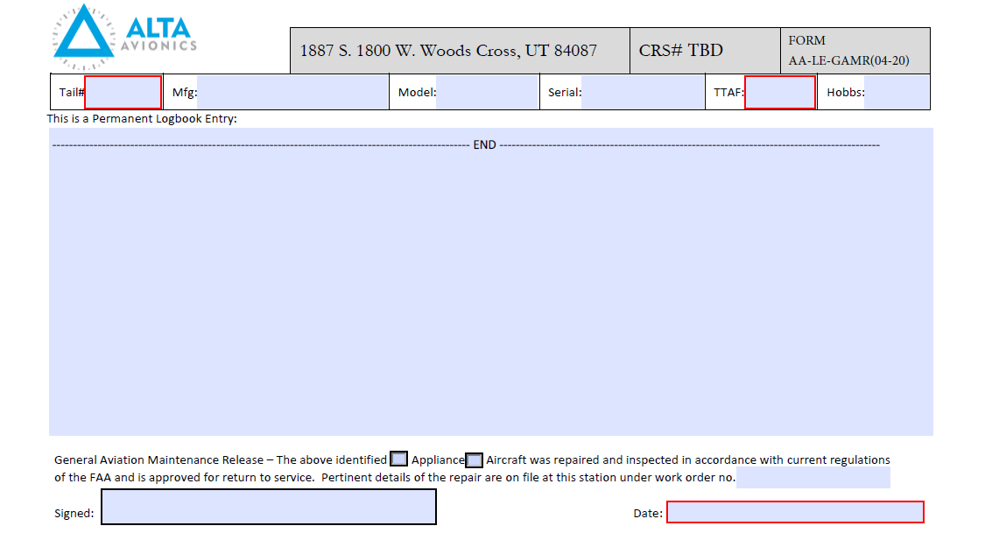

# AA-LE-ACMR – AIR CARRIER MAINTENANCE RELEASE

This for is used for Air Carrier logbook entries upon the aircraft being released back into service. The technician will document the applicable information when completing tests/inspections, and it will be signed by an authorized inspector. This sticker is to be placed in aircraft logbook, and electronically stored.

AA-LE-ACMR – INSTRUCTIONS

1. Enter Tail Number of Aircraft in Tail# box
2. Enter Manufacturer in Mfg box
3. Enter Model Information in Model box
4. Enter Manufacturer Serial Number in Serial Box
5. Enter Total Time Airframe in TTAF in TTAF box (if applicable)
6. Enter Hobbs information in box (if applicable)
7. Enter Description of work performed for return to service in large box
8. Checkmark applicable box of Appliance or Aircraft
9. Enter work order no.
10. Sign (authorized to RTS)
11. Enter present date

NOTE: Not all fields always require text entry. Contact your supervisor if there are questions. In cases where data is not required, DO NOT leave blank; enter N/A.

AA-LE-ACMR – SAMPLE

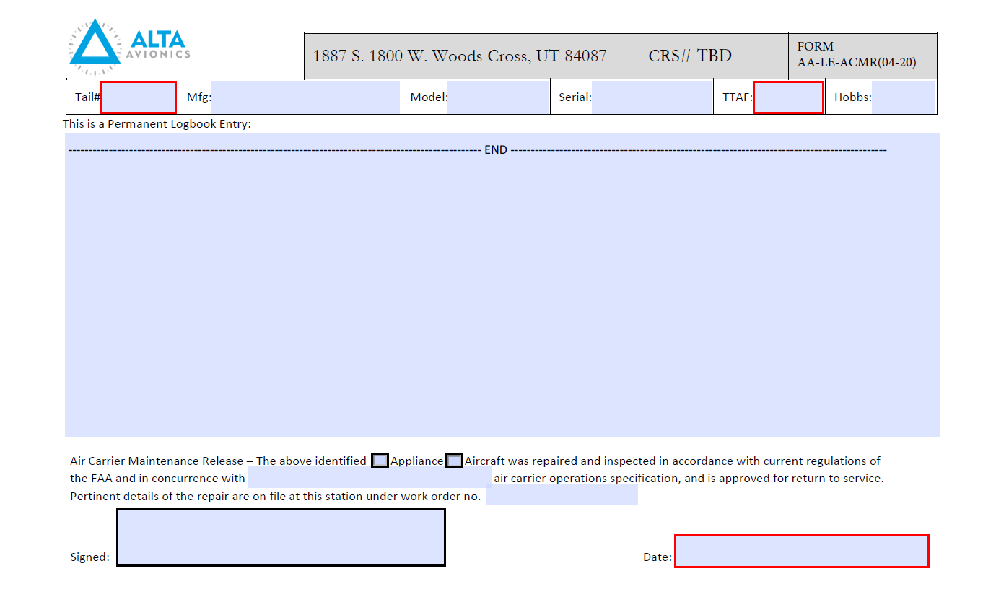

# AA-LE-ATI - LOG ENTRY ALTIMETER TEST AND INSPECTIONS

Used as a Log Entry for Altimeter tests and inspections. The technician will document the applicable information when completing tests/inspections per 14 CFR Parts 91.411, 91.413, 91.217, and it will be signed by an authorized inspector. This sticker is to be placed in aircraft logbook, and a copy thereof stored for two (2) years per 145.219.

AA-LE-ATI INSTRUCTIONS

1. Enter an X in the box, if appropriate, denoting compliance with Appendix E & F of 14 CFR 43, as required by 14 CFR 91 §91.411

2. Enter an X in the box, if appropriate, denoting compliance with Appendix F of 14 CFR 43, as required by 14 CFR 91 §91.413

3. Static System Leak Check;

a. Enter the altitude, in feet, a given system is tested to

4. Location Performed; enter the airport identifier where the work was performed as the location

5. Equipment Identification;

a. For all installed equipment comprising the pitot/static/transponder system;

b. Enter the Manufacturer’s name

c. Enter the Manufacturer’s Model Number

d. Enter the Manufacturer’s Part Number

e. Enter the Manufacturer’s Serial Number

f. Enter the value (in feet above sea level) the individual equipage was tested

6. Enter the Work Order number under which the tests and inspections are being performed

7. Enter the aircraft Manufacturer’s Model Number

8. Enter the aircraft Manufacturer’s Serial Number

9. Enter the aircraft registration number

10. Enter the aircraft Hobbs (hour) Meter time

11. Enter the aircraft tachometer (hours) time

12. Enter comments regarding the performance or functionality, as needed

13. Apply the signature of the person authorized to perform the tests and inspections, and return for service

14. Enter the date on which the tests and inspections were completed

NOTE: Not all fields always require text entry. Contact your supervisor if there are questions. In cases where data is not required, DO NOT leave blank; enter N/A.

AA-LE-ATI SAMPLE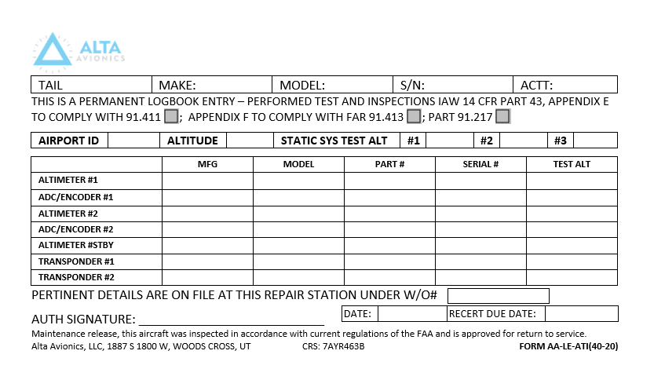

# FAA 8130-3

The FAA form is attached to repaired and/or tested units that are found to be serviceable. It will be completed and signed by an authorized inspector and remain with the unit. The completed form will be stored in Alta Avionics, LLC computer system. The most current form can be found on the FAA website under forms and by typing in 8130-3.or at

<https://www.faa.gov/forms/index.cfm/go/document.information/documentID/186171>

FAA 8130 INSTRUCTIONS

The instructions for the completion of an FAA 8130 form can be found in the document library of the FAA

Or by the following link

<https://www.faa.gov/documentlibrary/media/order/faa_order_8130.21h.pdf>

FAA 8130 SAMPLE

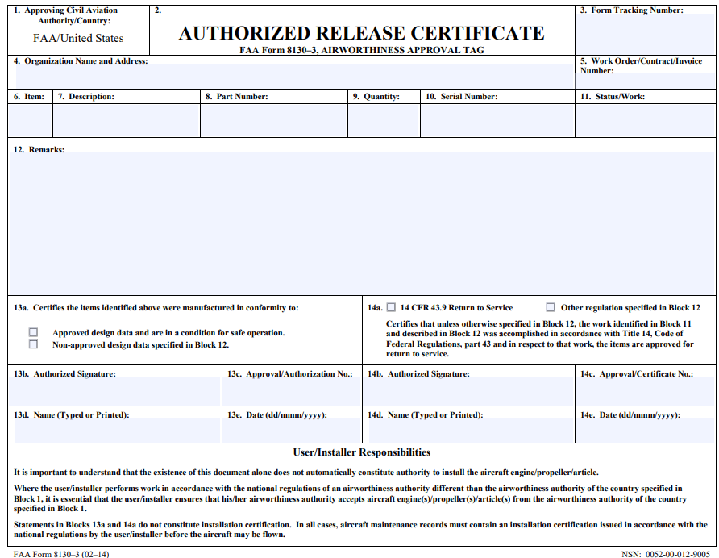

# AA-CC – CERTIFICATE OF CALIBRATION

This form is used to document the calibration of instruments/appliances that are calibrated under standards that are based on NIST standards or derived. The completed form will be added to the workorder and any appropriate records.

|  |  |
| --- | --- |
| AA-CC INSTRUCTIONS  1. Enter the name of the manufacturer for the unit being calibrated  2. Enter the model number of the unit being calibrated  3. Enter a description (nomenclature) of the unit being calibrated  4. Enter the serial number of the unit being calibrated  5. Enter the name of the customer who submitted the unit to be calibrated  6. Enter the work order number on which the work is being performed  7. Enter a description of the calibration procedures applicable to the unit being calibrated  8. Enter a description of the environmental conditions at the time the unit was being calibrated  9. Enter remarks pertaining to the unit being calibrated  10. Annotate in the boxes provided, the status the unit was found to be upon arrival  11. List all equipment and standards used to accomplish the calibration  12. Enter the date the calibration was completed  13. Enter the next calibration due date, based on the interval prescribed for the unit being calibrated  14. Enter the name of the person who performed the calibration  NOTE: Not all fields always require text entry. Contact your supervisor if there are questions. In cases where data is not required, DO NOT leave blank; enter N/A. | AA-CC SAMPLE |

# AA-CLEF - CAPABILITIES LIST SELF EVALUATION

This form will be used to evaluate the proposed repair station that is requesting an added capability to the Ops Specs’ limited rating.

AA-CLEF INSTRUCTIONS

1. Enter a description of the capability sought Facility;

a. The repair station with managerial control of its satellite repair stations must hold the capability prior to that capability being held by a satellite repair station

b. Select Yes or No, regarding housing and facilities

c. Describe the housing and facilities which are required to support the added capability

2. Requirements;

a. Select Yes or No, regarding the possession of proper tooling

i. Describe the type of tooling required

b. Select Yes or No, regarding the possession of proper equipment and materials

i. Describe the type of equipment and materials required

c. Select Yes or No, regarding the possession of the proper technical data required

i. Describe the type of technical data required

d. Select Yes or No, regarding the repair station employee for proper training

i. Describe the type of training required

3. Acceptance;

a. Provide the completed form to the Quality Assurance Manager

i. The Quality Assurance Manager will sign and date the form, and present to the President for final acceptance

NOTE: Not all fields always require text entry. Contact your supervisor if there are questions. In cases where data is not required, DO NOT leave blank; enter N/A.

AA-CLEF SAMPLE

/Users/croe10/workspace/RepairServiceManual/FM/AA-FORMS/AA-CLSE/AA-CLSE.pdf

# AA-CSDS – COMPASS SWING DOCUMENT SHEET

This form is used to document the data found while doing a compass swing. The completed form will be added to the workorder and any appropriate records.

AA-CSDS INSTRUCTION

1. Enter the Date of the Compass Swing

2. Enter the Work Order on which the Compass Swing is being accomplished

3. Enter the Aircraft Registration Number

4. System #1

a. Record the Compass Cardinal Headings, and the associated HIS and Wet Compass Readings (after corrections and adjustments)

5. Enter the name of the person performing the Compass Swing Check

6. System #2

a. Record the Compass Cardinal Headings, and the associated HIS and Wet Compass Readings (after corrections and adjustments)

7. Enter the name of the person performing the Compass Swing Check

NOTE: Not all fields always require text entry. Contact your supervisor if there are questions. In cases where data is not required, DO NOT leave blank; enter N/A.

AA-CSDS SAMPLE



# AA-ECTCR – ELECTROMAGNETIC COMPATABILITY TEST COMPLETION RECORD

used when conducting DO-160 testing of components. The technician will complete and sign the form upon completion of testing. Completed forms will be added to the workorder and any appropriate records.

|  |  |
| --- | --- |
| AA-ECTR INSTRUCTIONS   1. Enter the name of the person or company for whom this Compatibility Test is being accomplished 2. Enter the Work Order number on which this Compatibility Test is being accomplished 3. Enter the nomenclature (name) of the system, unit, aircraft for which this Compatibility Test is being accomplished 4. Enter the model and part number of the system, unit, aircraft for which this Compatibility Test is being accomplished 5. Enter the Identification number of the system, unit, aircraft for which this Compatibility Test is being accomplished 6. Enter the date on which this Compatibility Test is to begin 7. Enter the date on which this Compatibility Test is to be completed 8. Enter the name of the engineer or qualified person who is conducting this Compatibility Test 9. Enter the date of completion of the test 10. Enter the name of the Quality Assurance representative overseeing this Compatibility Test 11. Enter the date of acceptance by Quality Assurance of the test   **NOTE**: Not all fields always require text entry. Contact your supervisor if there are questions. In cases where data is not required, DO NOT leave blank; enter N/A. | AA-ECTR SAMPLE |

# AA-ATI-ALTIMETER TEST AND INSPECTION

This form is used when Testing/Inspecting the condition and operation of an Altimeter as per 14 CFR Part 43, Appendix E. The completed form will be added to the workorder and any appropriate records.

|  |  |
| --- | --- |
| AA-ATI INSTRUCTIONS   1. Enter the Work Order number on which the work is being performed 2. Place an X in the box next to the position of the Altimeter 3. Enter the name of the Manufacturer of the Altimeter 4. Enter the Part number of the Altimeter 5. Enter the Model number of the Altimeter 6. Enter the Serial Number of the Altimeter 7. Enter the name of the Manufacturer of the Encoder or Air Data Computer 8. Enter the Encoder or Air Data Computer Part Number 9. Enter the Model of the Encoder or Air Data Computer 10. Enter the Serial Number of the Encoder or Air Data Computer 11. Enter the Scale Error next to each parameter 12. Enter the Barometric Scale Error next to each parameter 13. Enter the value of Hysteresis for each parameter 14. Enter the value of the Case Leak as tested 15. Enter the values for the three (3) parameters of the After Effect following the test 16. Enter the aircraft registration number 17. Enter the date on which the Altimeter Test was completed 18. Enter the Identification number of the test equipment used 19. Enter the name of the person who performed the Altimeter Test 20. Place employee initials in the boxes for each Inspection   **NOTE**: Not all fields always require text entry. Contact your supervisor if there are questions. In cases where data is not required, DO NOT leave blank; enter N/A. | AA-ATI SAMPLE |

# AA-MACS -MASTER ALTIMETER CORRECTION SHEET

Used when calibrating pitot/static test equipment and/or altimeters. The technician will document the results of the calibration and/or test, and sign. The completed form will be added to the workorder and any appropriate records.

AA-MACS INSTRUICTIONS

1. Enter the date the Master Altimeter is being checked

2. Enter the name of the person performing the check

3. Enter the Part Number of the unit being checked

4. Enter the Serial Number of the unit being checked

5. Altimeter Pressure

a. Enter the values for all parameters, as tested

6. Friction Test

a. Enter the values for all parameters, as tested

7. Tolerances

a. Enter the values for all parameters, as tested

NOTE: Not all fields always require text entry. Contact your supervisor if there are questions. In cases where data is not required, DO NOT leave blank; enter N/A.

AA-MACS SAMPLE

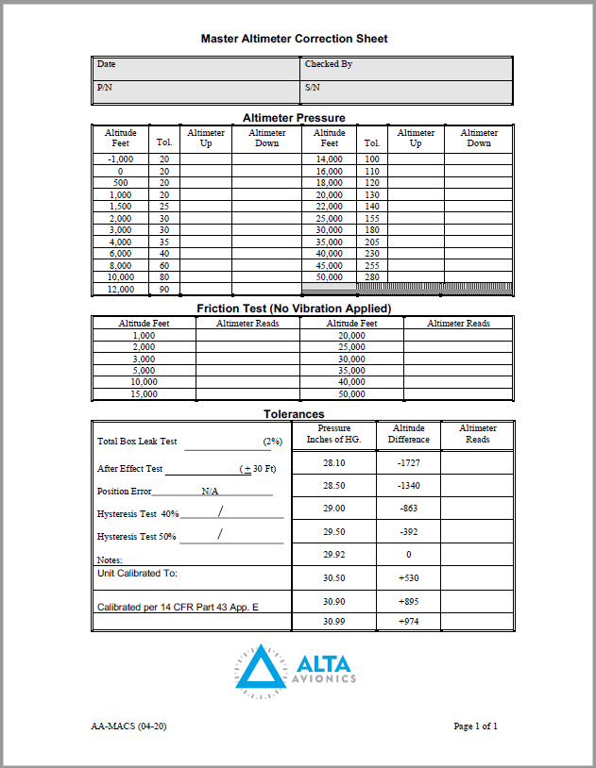

# AA-TS – TESTED STICKER

Used for altimeter tests. When an altimeter has been tested per 14 CFR Part 43, Appendix E. The technician will complete, and place the sticker on the altimeter.

|  |  |
| --- | --- |
| AA-TS INSTRUCTIONS   1. Enter Altitude Altimeter tested to 2. Enter Work Order Number 3. Enter Date performed | AA-TS SAMPLE |

# AA-CS – CALIBRATION STICKER

Used for “in-house” equipment calibration. When the calibration is completed, this sticker will be completed by the technician, and placed on the equipment.

|  |  |
| --- | --- |
| AA-CS – INSTRUCTIONS   1. Enter Calibrated Identification Number 2. Enter Date (MM/YY) Calibration Testing and servicing completed 3. Enter Date Next Calibration Due (MM/YY) 4. Initial of qualified personnel conducting calibration 5. Place sticker on instrument/tool calibrated. | AA-CS – SAMPLE |

# AA-ML MANUAL LABEL

Used on technical manuals to show their status. The technician will check to see if manual is current, reference only, or static, and document current status on the label with initials and date.

|  |  |
| --- | --- |
| AA-CS – INSTRUCTIONS   1. Place sticker on manual (if sticker present continue to step 2) 2. Enter date manual checked for currency. 3. Enter Reference, Static or Current. 4. Initial of personnel | AA-CS - SAMPLE |

# AA-ID - ID TAG

Affixed to received appliances undergoing benchwork for tracking purposes. The tag will remain with the unit until returned for additional work.

|  |  |
| --- | --- |
| AA-ID - INSTRUCTIONS   1. Fill with corresponding work order number 2. Affix to unit 3. Mark box that Identifies type of work performed   “NEW”, “O.H.”, “REPAIRED” or “OPS CHK”.   1. Enter “THRU” date. | AA-ID - SAMPLE |

# AA-SLI SHELF LIFE ITEM

Attached to all shelf life items. Completed by the Parts Inspector, showing a Control #, and expiration date, and attached to each shelf life item. The tag will remain on each item until used, or disposed of.

|  |  |
| --- | --- |
| AA-SLI – INSTRUCTION   * + 1. Enter expiration of limited life item     2. Affix to item | AA-SLI – SAMPLE |

# AA-RAS – REMOVED AS SERVICABLE

Used to identify parts or appliances. The technician will complete, and attach this tag, to equipment removed during maintenance. It will remain attached to the equipment until reinstallation, and then destroyed.

|  |  |
| --- | --- |
| AA-RAS – INSTRUCTIONS   1. Enter description of nomenclature 2. Enter part number 3. Enter serial number 4. Enter Aircraft 5. Enter Aircraft N Number 6. Enter Work Order number 7. Enter Date tagged 8. (technician) write name 9. Enter reason for removal   10 enter any applicable remarks for nomenclature | AA-TS SAMPLES  Two Removed as serviceable tags are available shown below only one of which is necessary to be applied when utilized |
|  |  |

# AA-REP REPAIRABLE EQUIPMENT/PARTS

used to identify equipment/parts that are repairable. The technician and/or inspector will complete, and attach this tag, to equipment or parts that may be repairable. They will remain with the equipment/part until disposition, and then destroyed

|  |  |
| --- | --- |
| AA-REP – INSTRUCTIONS   1. Enter description of nomenclature 2. Enter part number 3. Enter serial number 4. Enter Aircraft 5. Enter Aircraft N Number 6. Enter Work Order number 7. Enter Date tagged 8. (technician) write name 9. Enter reason for removal   10 enter any applicable remarks for nomenclature  NOTE: Not all fields always require text entry. Contact your supervisor if there are questions. In cases where data is not required, DO NOT leave blank; enter N/A. | AA-REP – SAMPLE |
|  |  |
|  |  |

# AA-RFS REPAIRABLE FOR STORAGE

used to identify items that are repairable, to be placed in storage. The technician and/or inspector will complete, and attach this tag, to repairable items that are going to be placed into storage awaiting repair. The tag will be removed and destroyed, when unit is repaired and documented as serviceable or scrapped.

|  |  |
| --- | --- |
| AA-RFS – INSTRUCTIONS   1. Enter Manufacturer Information 2. Enter Model Information 3. Serial Number (S/N) 4. Enter Part Number (P/N) 5. Enter information regarding defect   NOTE: Not all fields always require text entry. Contact your supervisor if there are questions. In cases where data is not required, DO NOT leave blank; enter N/A. | AA-RFS – SAMPLE |

# AA-RIT – REJECT ITEM TAG

Placed on a rejected item. A technician and/or inspector will attach a properly completed tag to rejected parts. This tag will remain with the part and returned to the customer, or scrapped.

|  |  |  |
| --- | --- | --- |
| AA-RIT – INSTRUCTIONS   1. Affix to item in manner which is easily identifiable | AA-RIT- SAMPLE   |  | | --- | |  | |

# AA-ST SCRAP TAG

This tag is placed on items to be scrapped. The technician and/or inspector will place a completed tag on parts/appliances to be scrapped. When the parts/appliances have been scrapped, and documented in the proper manner, the tag will be destroyed.

|  |  |  |
| --- | --- | --- |
| AA-ST – INSTRUCTIONS   1. Enter present Date 2. Enter name 3. Enter Part Number after P/M 4. Enter Serial number after S/N | AA-ST – SAMPLE   |  | | --- | |  | |
|  |  |

# AA-SPL – SCRAPPED PARTS LOG

Used to document scrapped parts. This form will be completed and signed by an authorized inspector. The Chief Inspector, or his/her designee, will verify by signature. The form will be kept on file for not less than two years.

|  |  |
| --- | --- |
| AA-SPL – INSTRUCTIONS  *Note;:Use of this form is required only for aeronautical articles which are affected by 14 CFR 43, §43.10; Disposition of Life-Limited Aircraft Parts. Life Limited aircraft parts, are those parts for which the holder of a type design (aircraft, appliances, TSO articles, engines). Parts and aeronautical articles which are not subject to §43.10, may be discarded without retaining a record, unless otherwise directed by an aircraft operator.*   1. Enter a Description of the Scrapped Part 2. Enter the Manufacturer’s Part Number 3. Enter the Manufacturer’s Serial Number 4. Enter the name of the person performing the scrapping or mutilation operation 5. Enter the name of the person who verified the part was rendered beyond use 6. Enter the date on which the part was scrapped 7. Enter the Work Order Number under which the part was removed from service and scrapped   NOTE: Not all fields always require text entry. Contact your supervisor if there are questions. In cases where data is not required, DO NOT leave blank; enter N/A. | AA-SPL – SAMPLE |

# AA-TECIF – TEST EQUIPMENT CALIBRATION AND INSPECTION FORM

This form is used for inhouse equipment calibration. This form will be completed by the technician performing the calibration of the equipment, and will be signed by an inspector. The completed form will be added to any appropriate records.

|  |  |
| --- | --- |
| AA-TECIF – INSTRUCTIONS   * + 1. Enter record number     2. Enter make information of unit being inspected     3. Enter model information of unit being inspected     4. Enter serial number of units being inspected     5. Enter date calibration occurred     6. Enter date next calibration due     7. Enter reference information make/model     8. Enter serial number of references used     9. Enter record number     10. Enter additional reference standards as applicable utilizing steps 7-9     11. qualified technician enters name after Calibrated by     12. qualified technician enters name after Inspected by | AA-TECIF - SAMPLE |